ASSIGNMENT3
Name:T.B.P.Hariharan RollNo:2019102019

1.The Netlist for the circuit is shown below
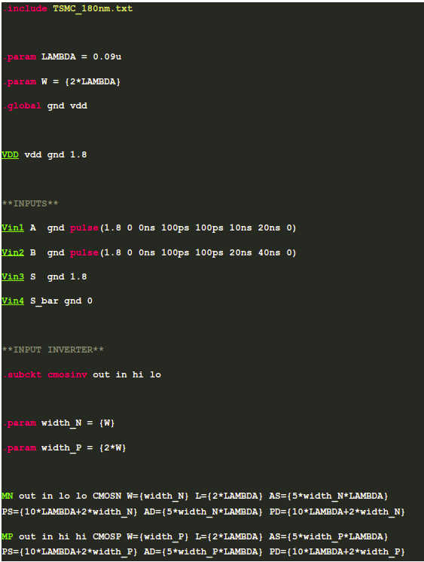

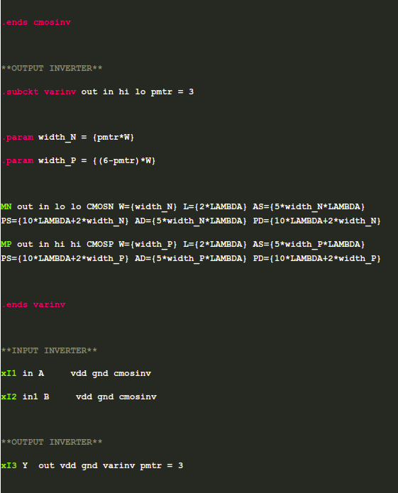

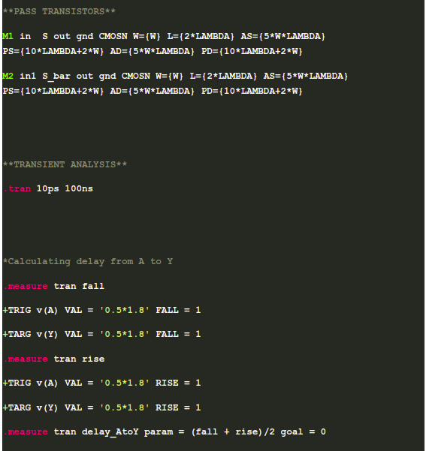

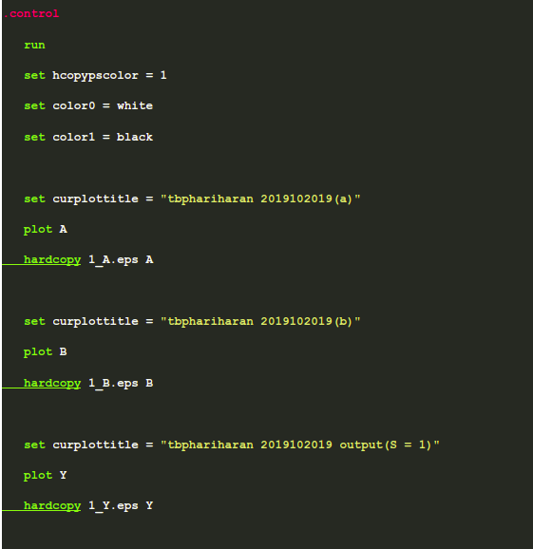

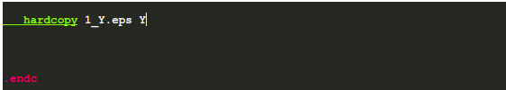

Wp = (6 – k)W , Wn = kw.
For Width(W) = 4 * LAMBDA(least possible value as per design rule checker) , LAMBDA = 0.09 micron .
The minimum average delay is observed to be 1.21463 * 10⁻¹⁰ seconds when K = 4,
Wn = 4W,Wp = 2W.
Here We are finding delay for S = 1 we can find it for S = 0 but both give same result, it is sufficient to calculate for S = 1 or S = 0.
Simulation Results From NGSPICE.
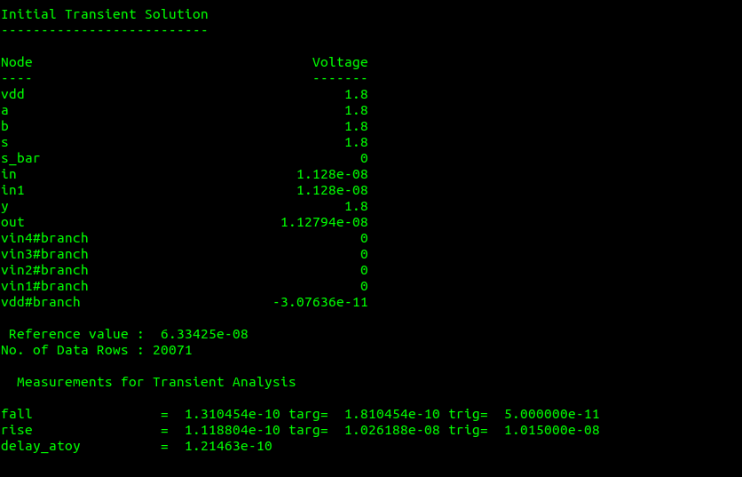

Plots:
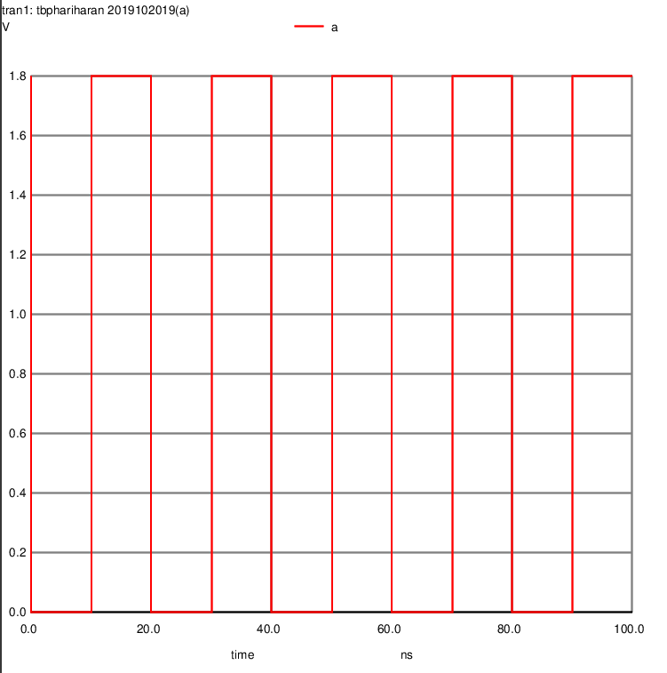
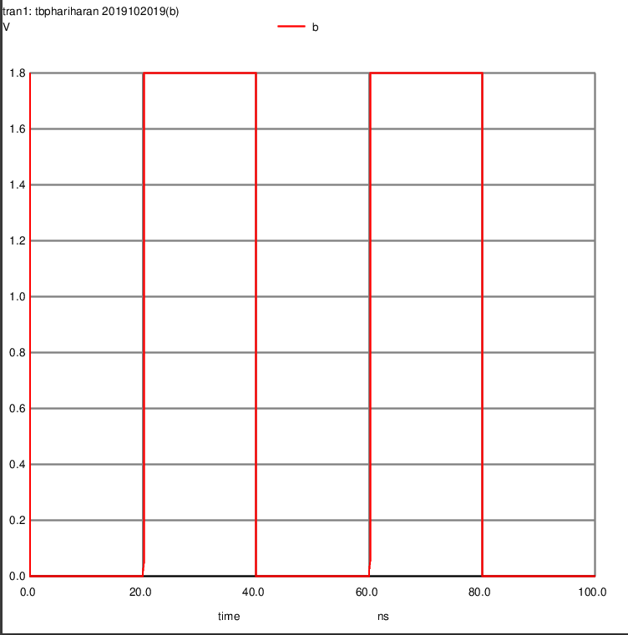
Input a Input b
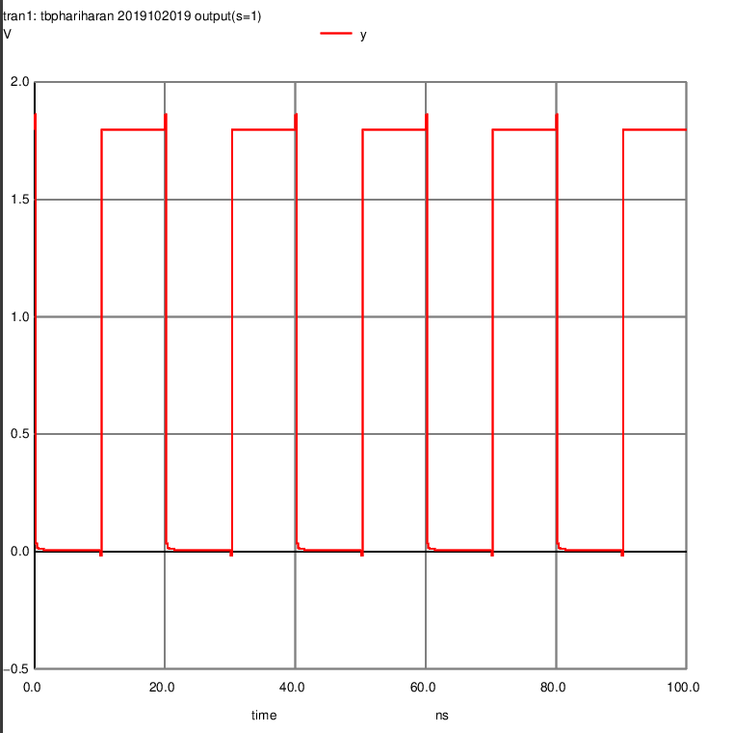

Output Y
2(a).The Shannon Expansion and Circuit diagram are shown
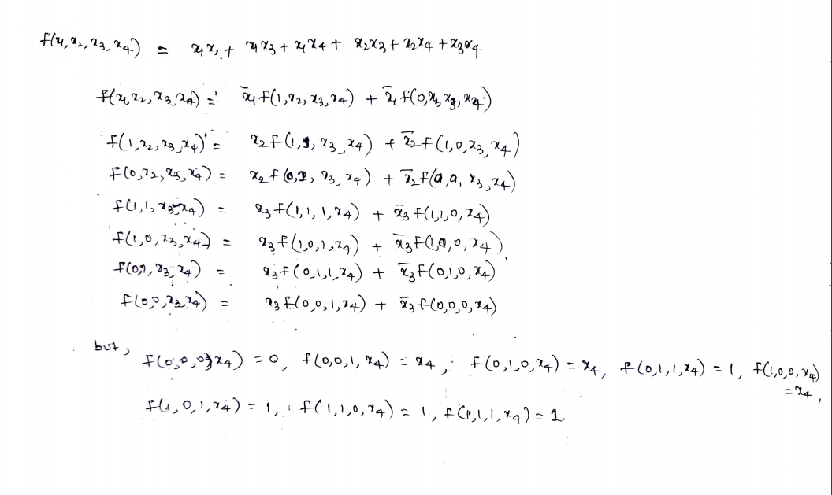
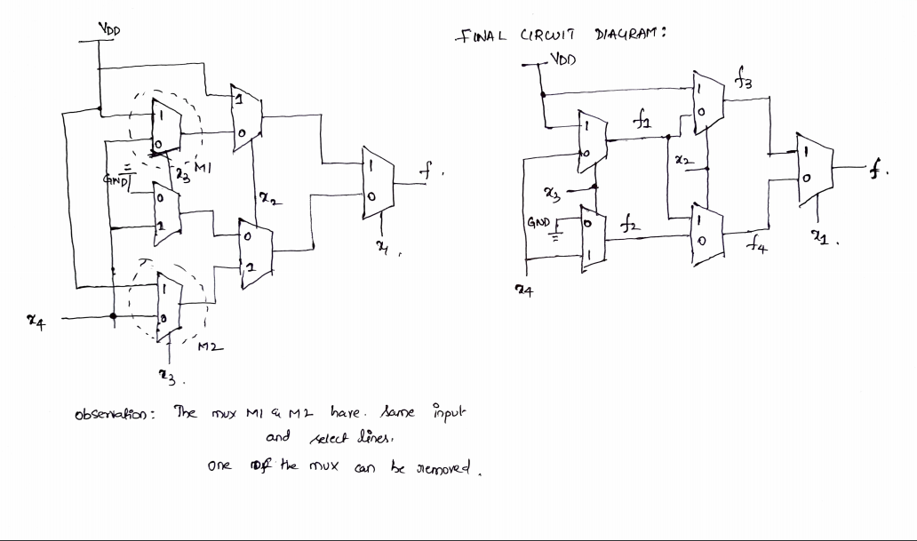

2(b).The netlist For the above circuit is shown
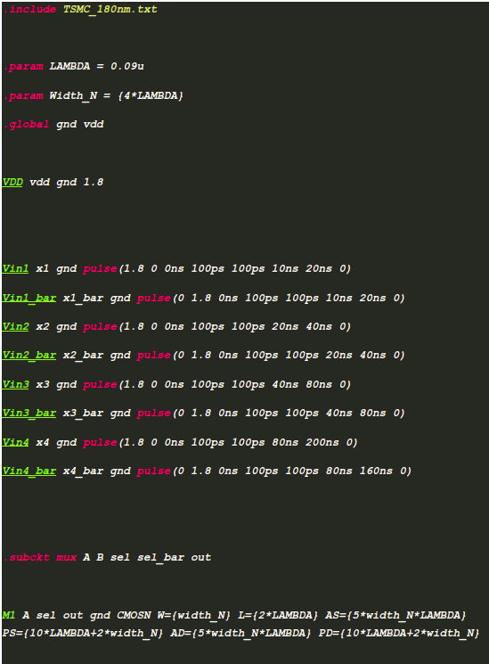

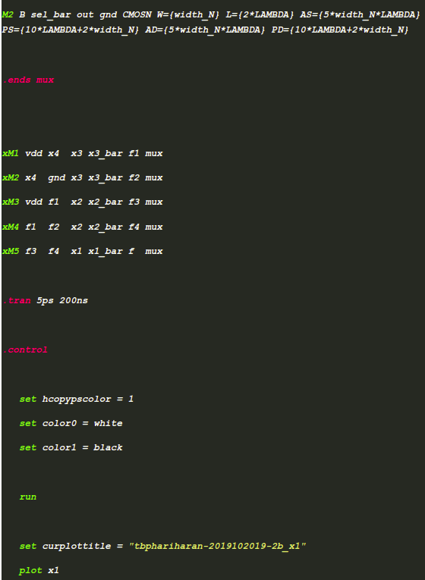

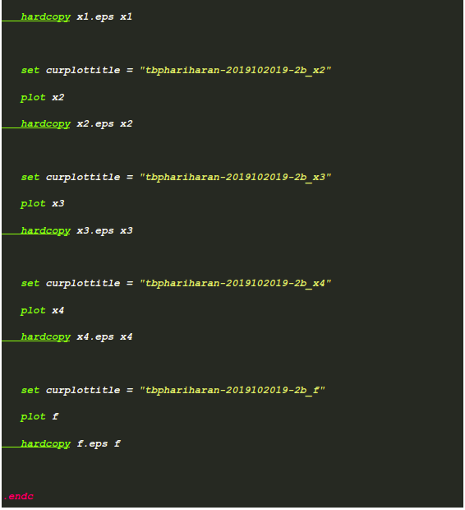

Plots :
Inputs :
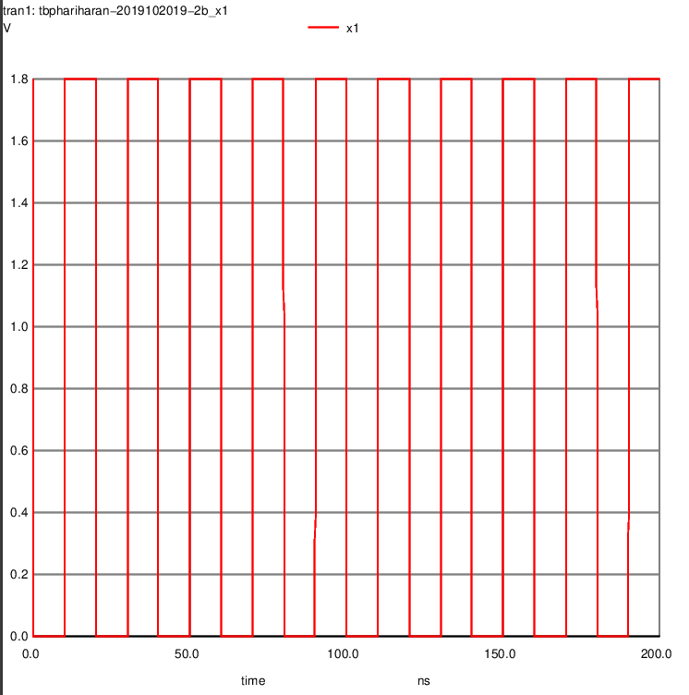
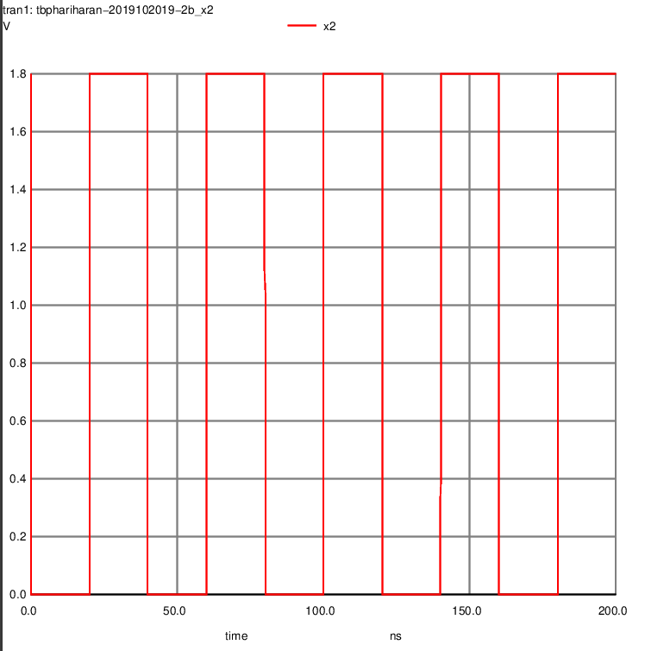
x1 x2
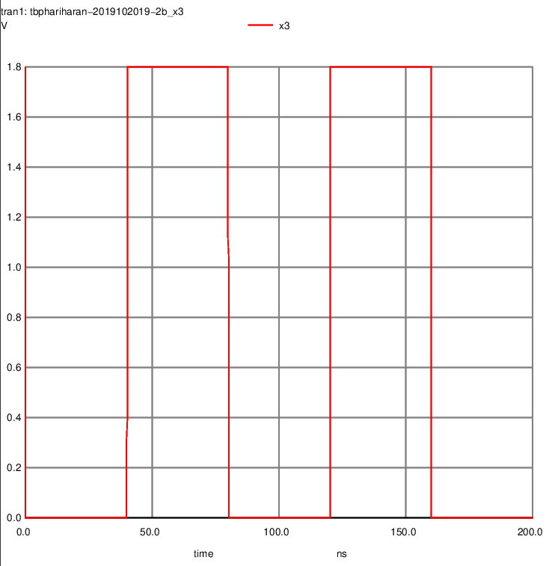
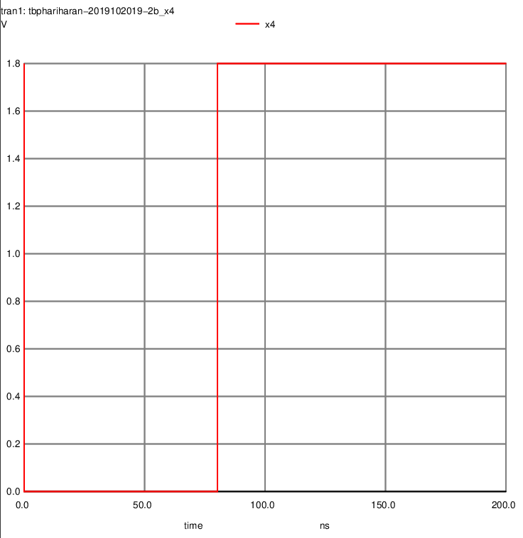
x3 x4
Outputs:
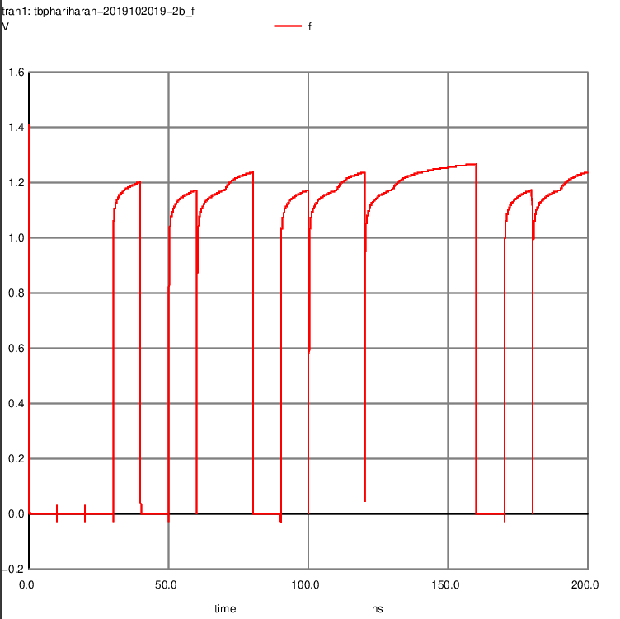
f = x₁x₂ + x₁x₃+x₁x₄+x₂x₃+x₂x₄+x₃x₄

2(c).
f(x₁ , x₂ , x₃ , x₄) = x₁x₂ + x₁x₃+x₁x₄+x₂x₃+x₂x₄+x₃x₄
Observation : If any two of the inputs are one the output will be 1.So to get output one all the inputs should not be necessarily one.
If any three of the inputs are zero the output will be 0.So to get output as zero all the inputs should not be necessarily zero.
Circuit Diagram Shown Below:
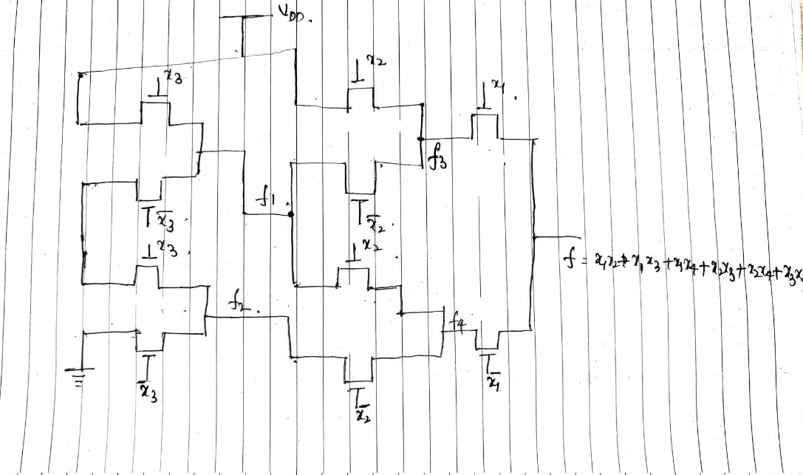

The Paths will be ,
Charging Path:
The Transistors having x2 and x1 as gates if x2 = 1 , x1 = 1 , then f will be 1.
Discharging Path:
The transistors having as gates if x3 = 0 , x2 = 0 , x1 = 0 , then f will be 0.
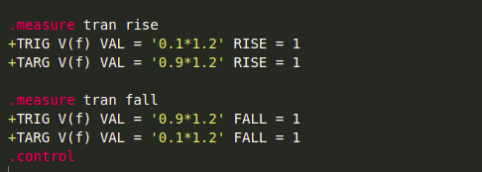

By adding the above snippet to the netlist in 2(a) we can find the rise and fall time.
From Graph the we get the maximum voltage to be 1.2(approximately).
The rise and fall time are shown below.
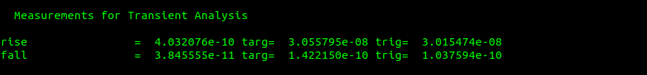
Initial State Final State
The input combinations for charging (0 , 0 , 0 , 0) = (1 , 1 , 0 , 0)
The input combinations for discharging (1 ,1 ,0 , 0) = (1 , 0 , 0 , 0)

2(d).The buffers have lower charging resistance and increased Drive capacity using this advantage this can decrease the rise time the buffer can be connected after the transistors having gates x1 and x2 , thus it decreases the rise time.

3.(a) state table is shown below
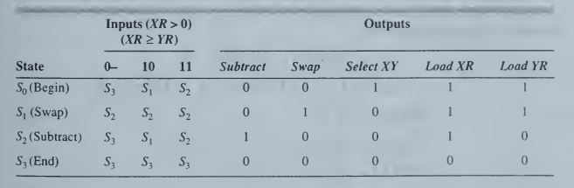
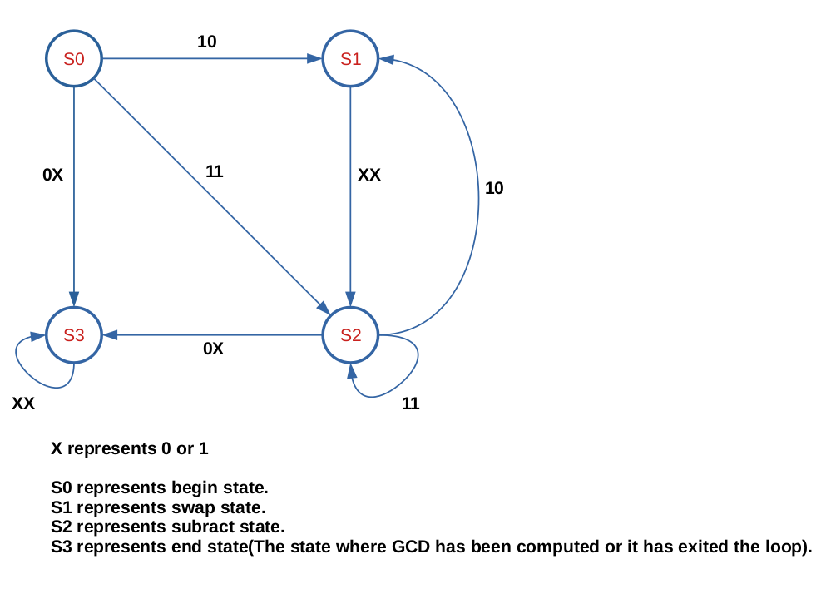
The state diagram for the above state table is shown below.

3(b).Clearly there are 4 states we require [log₂4] = 2, D-FlipFlops are required.
We assign binary codes to the states,
S₀ = 00 , S₁ = 01 , S₂ = 10 , S₃ = 11.
Let the output of First and Second D-FlipFlop be D₁ , D₀ respectively.
D₁, D₀ be the present state of the two FlipFlops.
D₁⁺, D₀⁺ be the next state of the two FlipFlops.
The Control Unit’s Combinational Logic is derived from the excitation table.
The excitation table is shown below

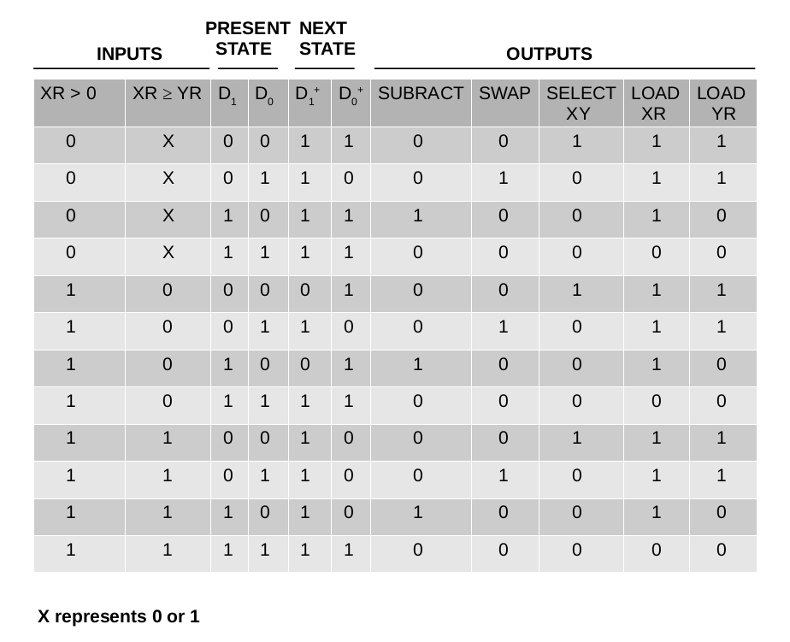
From the excitation table the control unit’s logic can be derived from KMAP
The KMAP for D₁⁺ is shown below
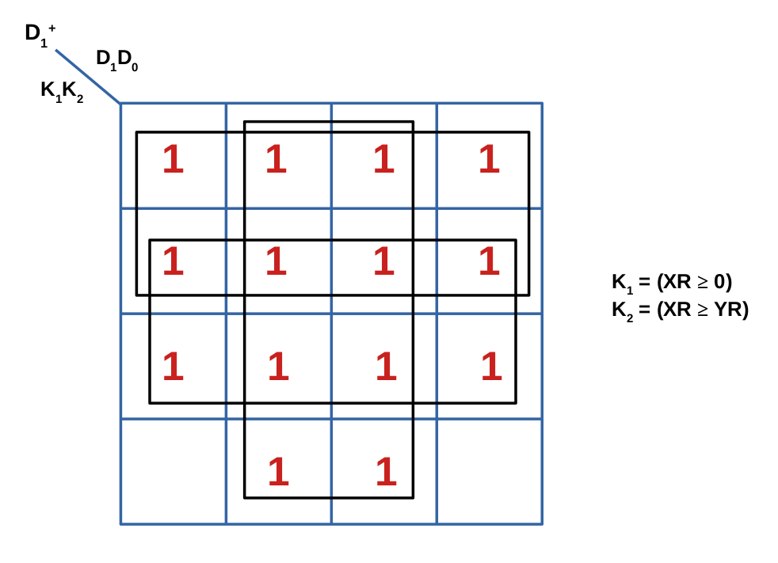
From the above KMAP,
D₁⁺ = + +
The KMAP for D₀⁺ is shown below
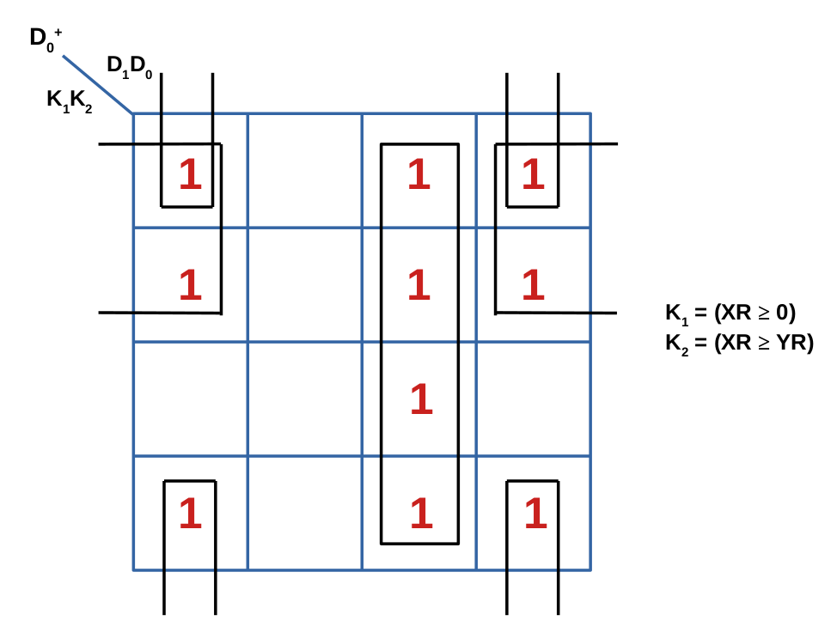
From the above KMAP,
D₀⁺ = + +
From the excitation table,
Subract =
Swap =
SelectXY(SXY) =
Load XR(LXR) =
Load YR(LYR) =
The circuit diagram for the CONTROL UNIT is shown below

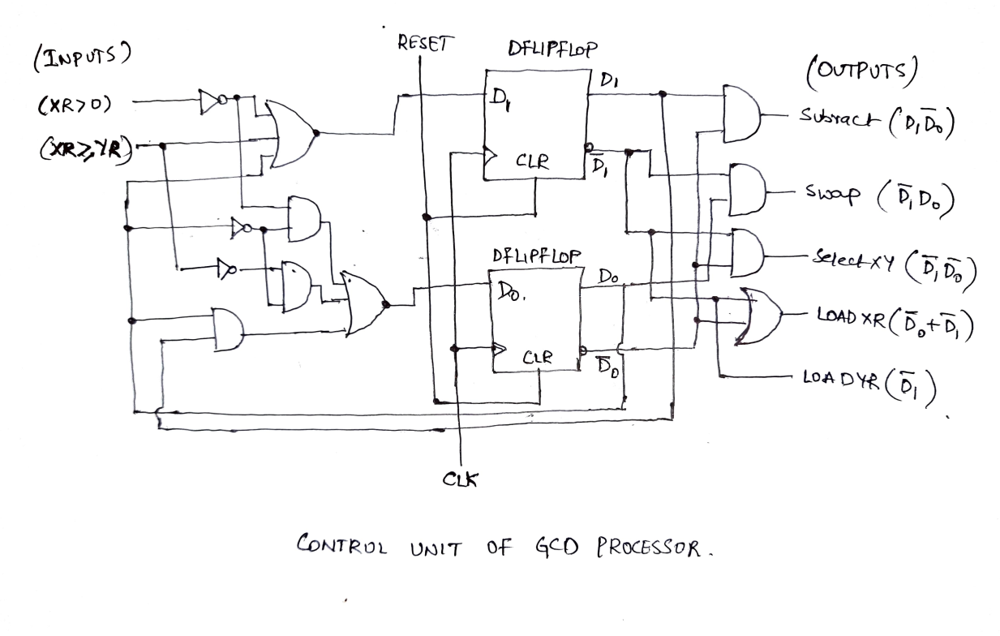
3(c).The Above Designed Control Unit is implemented in Verilog HDL.
In this implementation the Four states are encoded with binary codes
S0(begin) = “00”,S1(swap) = “01”,S2(Subract) = “10”, S3(End) = “11”.
In this implementation we are not using One Hot Encoding.
Implementation In verilog :
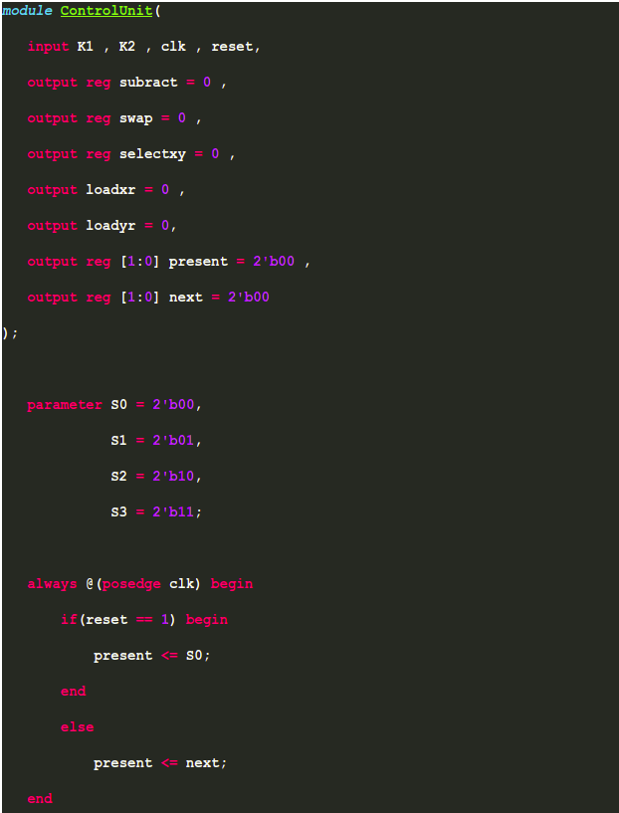

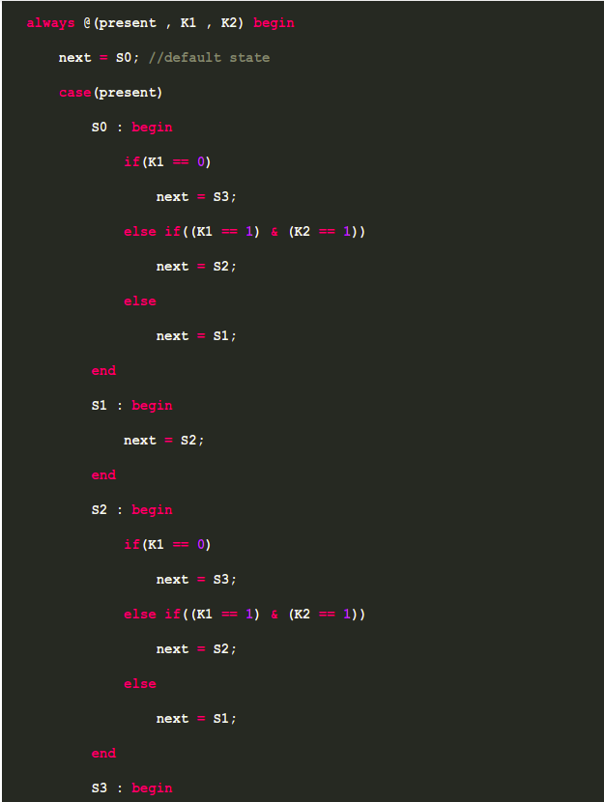

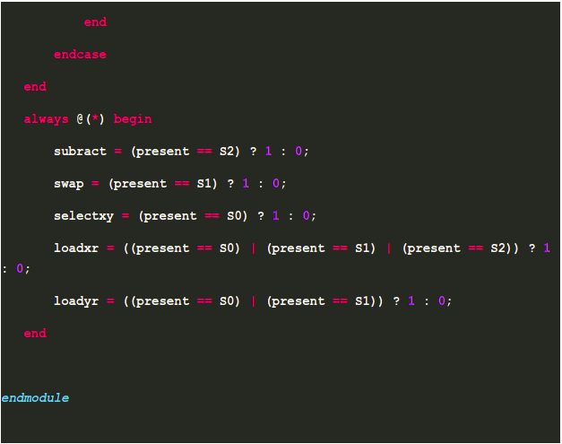

Simulation Results From GTKWave:
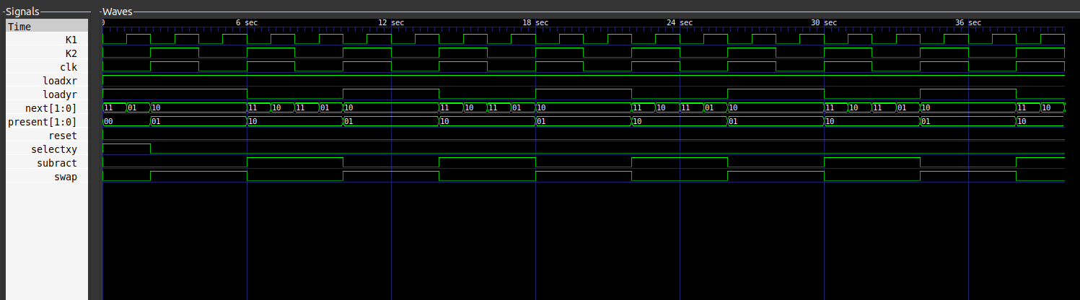
Where K1 = (XR > 0) , K2 = (XR ≥ YR) , clk is Clock Signal , loadxr is loading the register xr , loadyr is loading the register yr , next[1:0] represents next state of the Control Unit , present[1:0] represents present state of the control unit , reset is reset signal , selectxy is selecting the values x and y. Subract signal, Swap is Swap signal.
3(d).The behavioral description is shown below
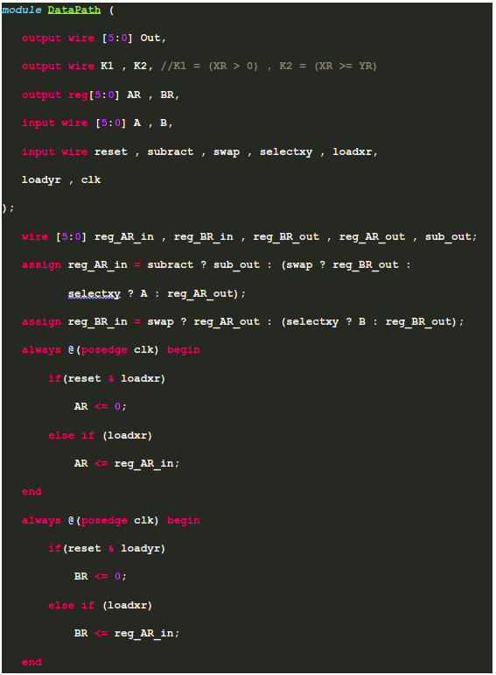

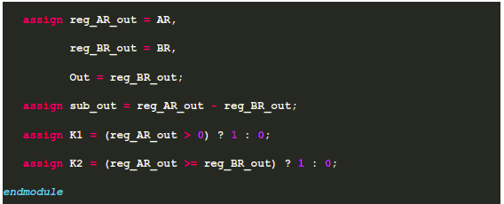

Simulation Results From GTKWave
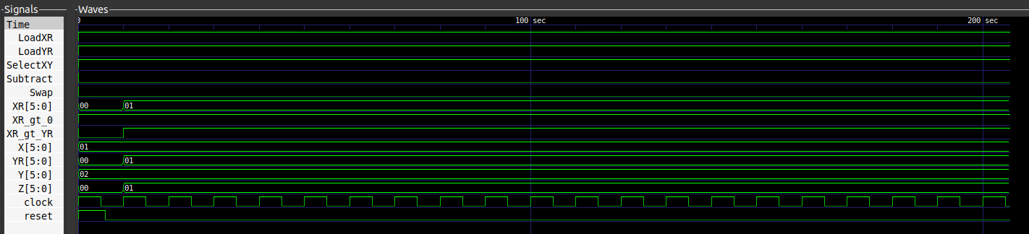
The behavioral description of the DataPath Unit is Shown Above.
It is simulated against X = 1 , Y = 2.
“XR_gt_0” represents XR > 0 , XR_gt_YR represents XR > YR. Z is the output of the GCD processor.
3(e).The below description computes GCD and the test bench is shown below.
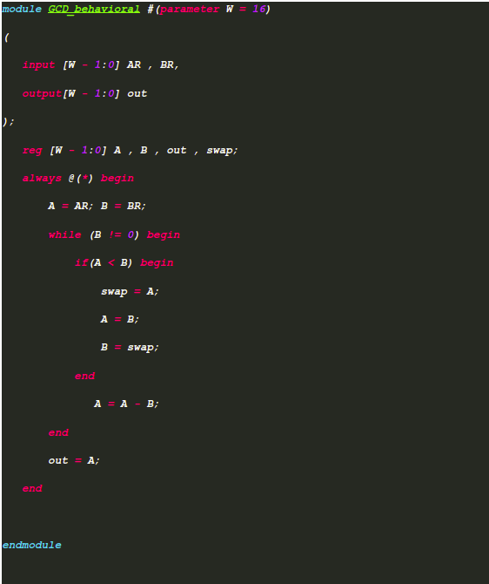

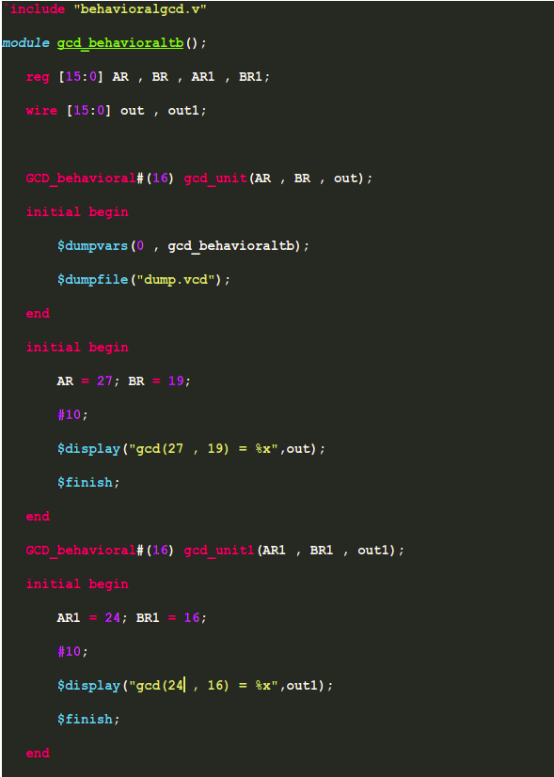

Simulation Results From GTKWave
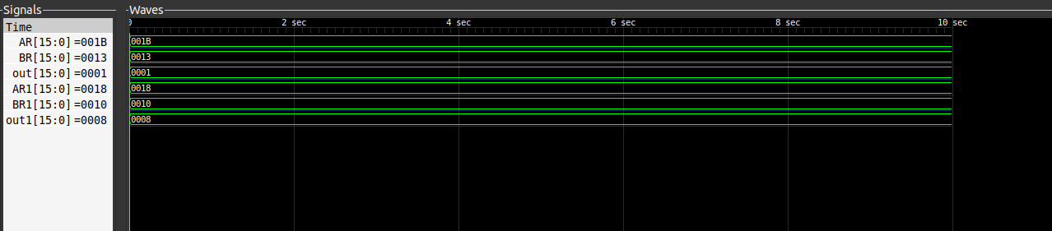
‘AR’ , ‘BR’ , ‘AR1’ , ‘BR1’ , ‘out’ , ‘out1’ are all 16 bit registers(It is a default value but it can be changed to either 32 or 64-bit with the help of parameter W).
‘AR’ represents the number 27 , ‘BR’ represents the number 19 , ‘out’ represents gcd(27 , 19) = 1, clearly the output of ‘out’ signal is 1.
‘AR1’ represents the number 24 , ‘BR1’ represents the number 16 , ‘out1’ represents gcd(24,16) = 8 , clearly the output of ‘out1’ is 8.

